Building an Email Campaign: Creating a brand launch email – using **Mailchimp**

**Brand Name**

**“ Gaming docs store ”**

Our Team members :

M. Viswanathan (TL)

J. Paranthaman

S. Praveen

V. Vishnuvarthan

We are from University College of Engineering BIT Campus, Trichy pursuing our Final year in ECE

**ABSTRACT:**

Email campaigning is a marketing strategy that involves sending targeted and personalized emails to a specific audience with the aim of promoting products, services, or ideas. This abstract explores the key elements and benefits of email campaigning.

The abstract begins by discussing the importance of building an email list and segmenting it based on demographics, interests, or previous interactions. It emphasizes the significance of crafting compelling subject lines and engaging content to capture recipients' attention and encourage them to open and read the emails.

Furthermore, the abstract highlights the value of personalization in email campaigns, such as addressing recipients by their names or tailoring content based on their preferences. It also emphasizes the need for clear call-to-action buttons that direct recipients to desired actions like making a purchase or signing up for a newsletter.

The abstract then delves into the benefits of email campaigning, including its cost-effectiveness compared to traditional marketing channels. It discusses how email campaigns allow businesses to reach a large audience at a relatively low cost while providing measurable results through open rates, click-through rates, and conversion rates.

Additionally, the abstract touches upon the ability of email campaigns to foster customer relationships through regular communication and targeted messaging. It highlights how businesses can use automated emails to nurture leads, provide valuable information, offer exclusive promotions, or request feedback.

Lastly, the abstract concludes by emphasizing that successful email campaigns require continuous monitoring and optimization based on performance metrics. It suggests testing different elements like subject lines, content formats, or send times to improve engagement rates and overall campaign effectiveness.

Overall, this abstract provides an overview of email campaigning as an effective marketing strategy that enables businesses to connect with their target audience in a personalized manner while achieving measurable results at a reasonable cost.

**INTRODUCTION :**

An email campaign is a targeted marketing effort that involves sending a series of emails to a specific group of subscribers. It can be used for various purposes such as promoting products or services, sharing news or updates, nurturing leads, or building customer loyalty.

Mailchimp provides a range of tools and features to help you create effective email campaigns. You can choose from a variety of customizable templates or design your own emails using the drag-and-drop editor. The platform also offers segmentation options, allowing you to target specific groups within your subscriber list based on criteria such as demographics or past interactions

**TOPIC:**

**Brand Name:** Gaming docs

**Category**: Gaming Accessories

**Target Audience:** Teenagers and Men

**Email:** gamingdocsstore@gmail.com

We have documented the process and have explained it step by step below:

**STEP 1:**

Go to “**mailchimp**” website and choose the “**Campaigns**” menu and click on the “**All campaigns**” option. And Select the **Create** **new** option and give a name to your campaign.

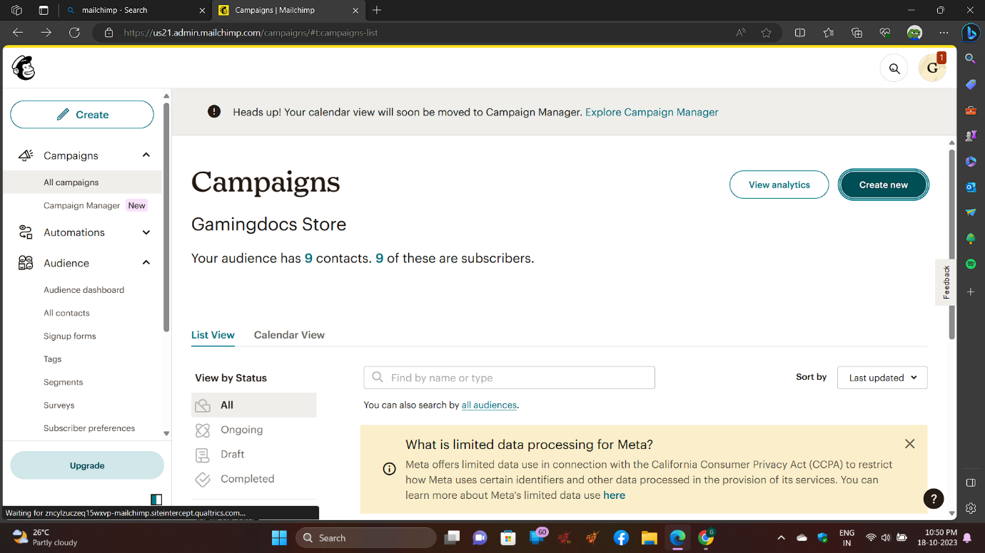

**STEP 2:**

Choose what to do and select the option you want.

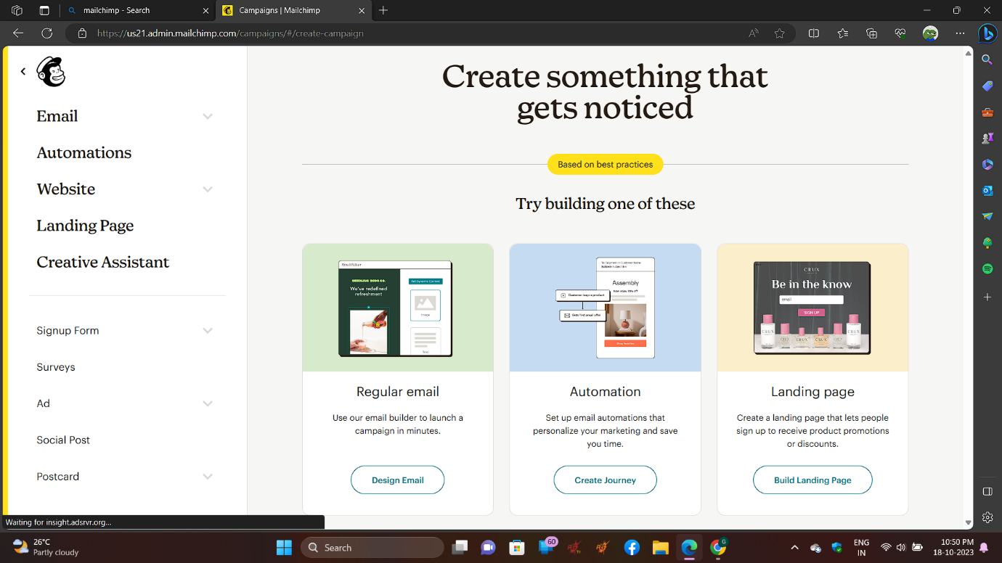

**STEP 3:**

Give the title of your Email Campaign

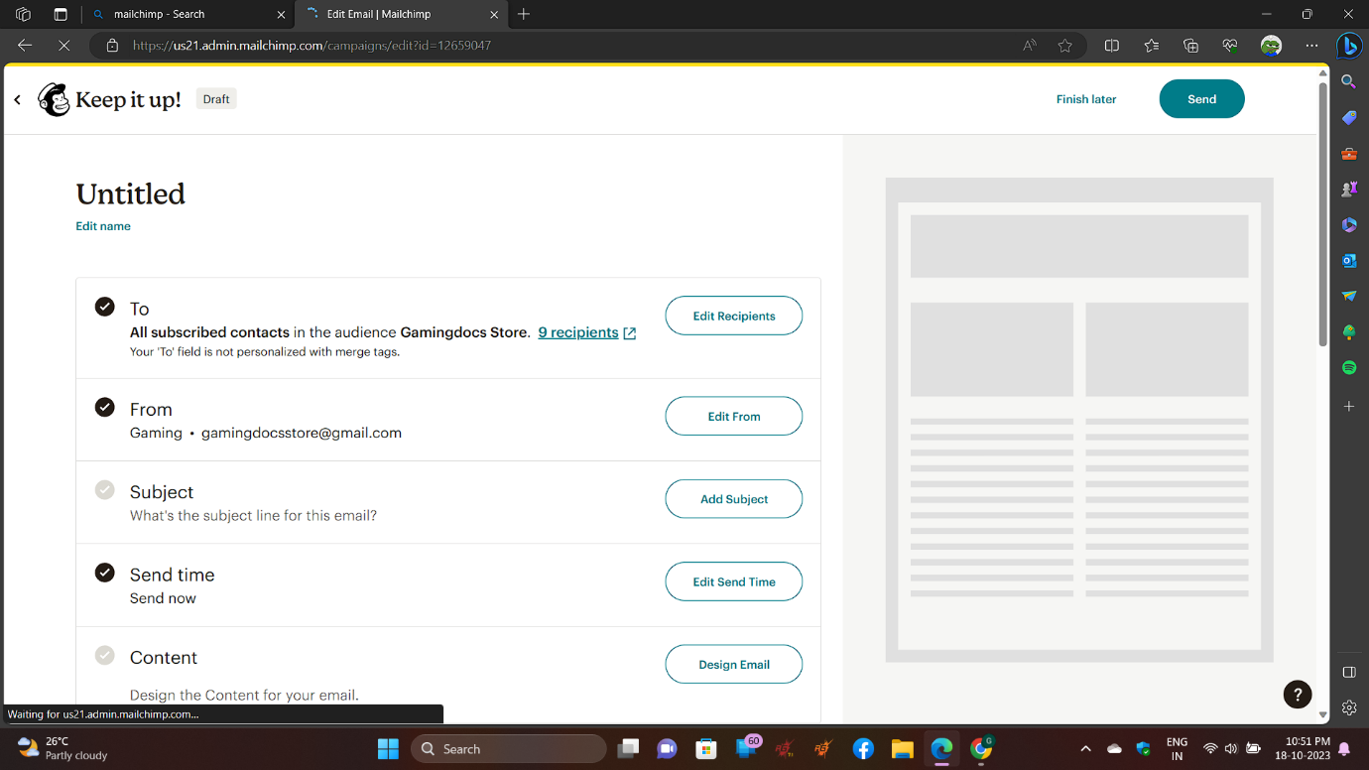

**STEP 4:**

Once the title is successfully given proceed to the next step

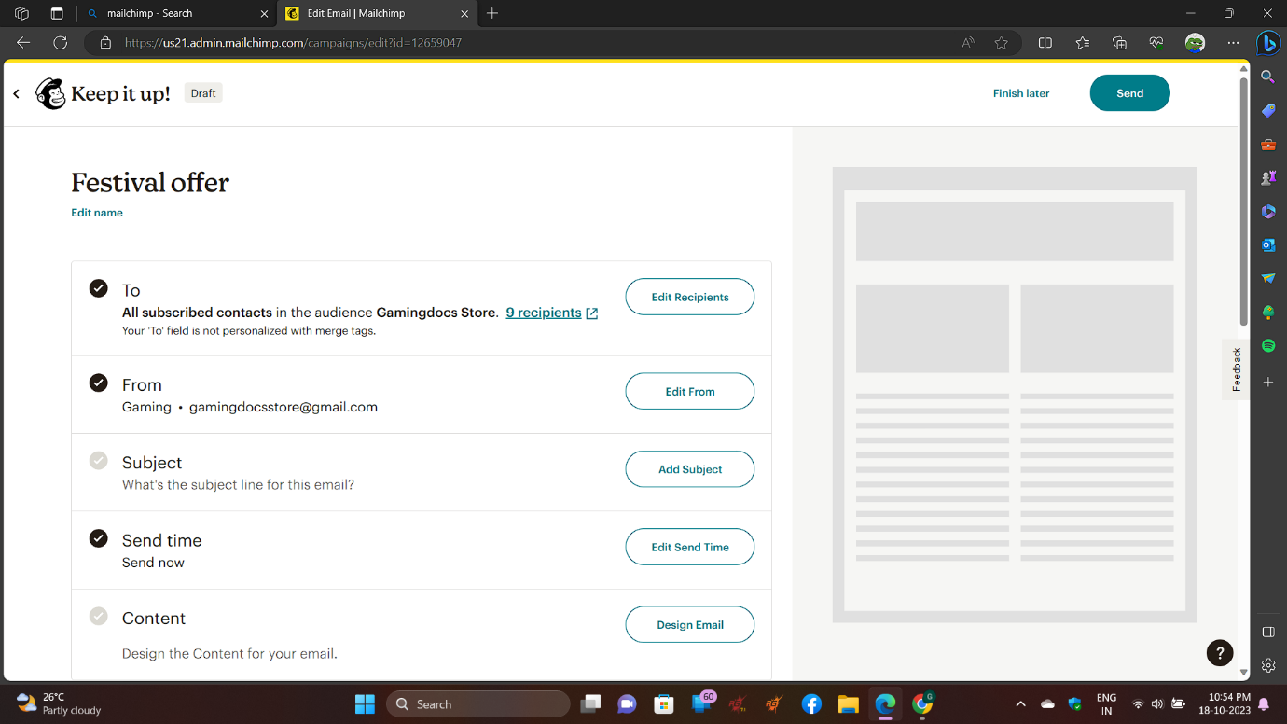

**STEP 5:**

Select the method you want to add contacts

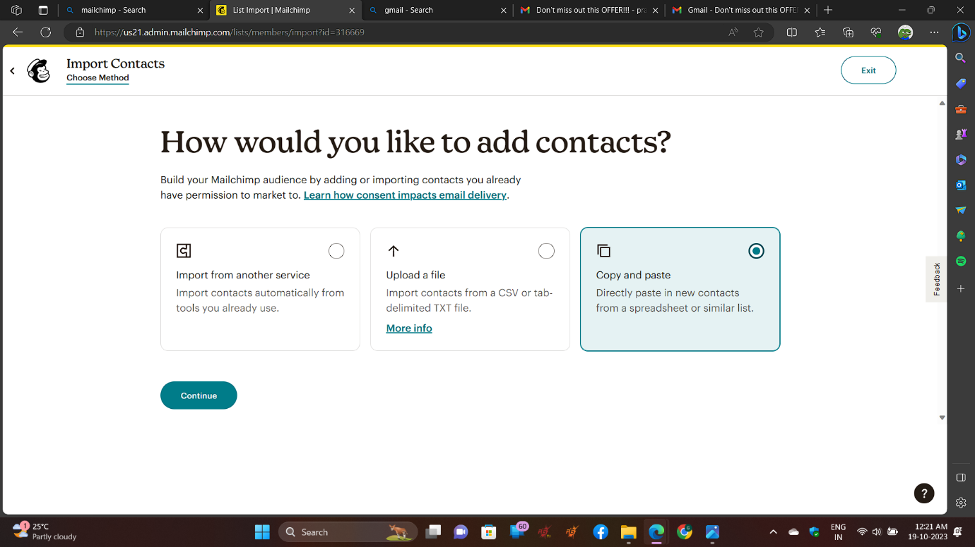

**STEP 6:**

Now copy and paste your contacts

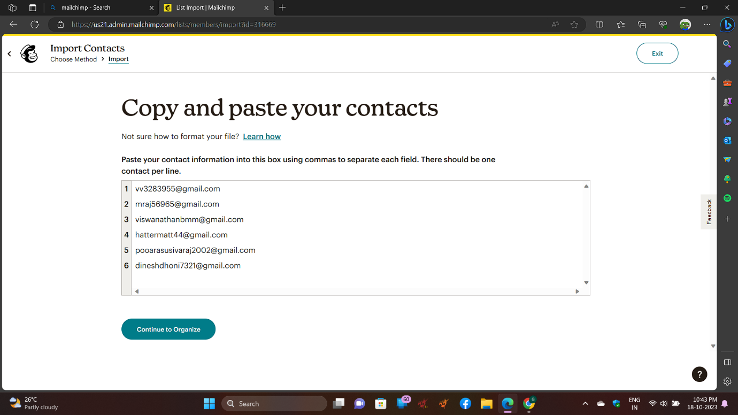

**STEP 7:**

And organize your contacts

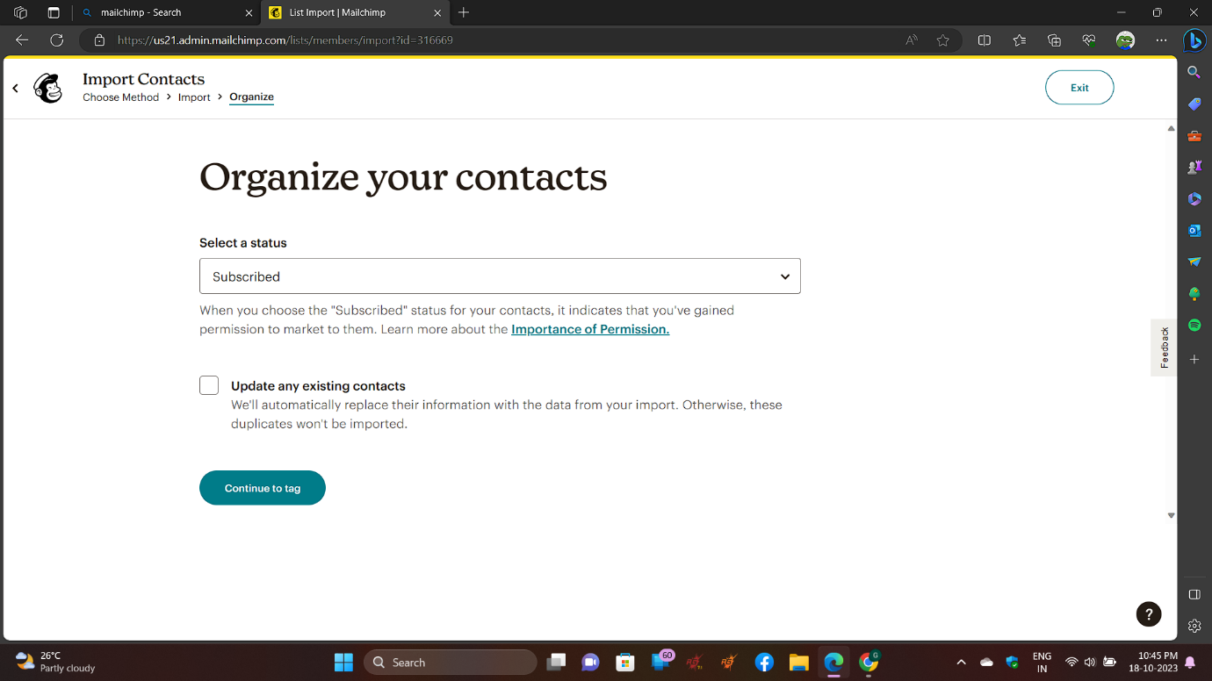

**STEP 8:**

Now tag your contacts

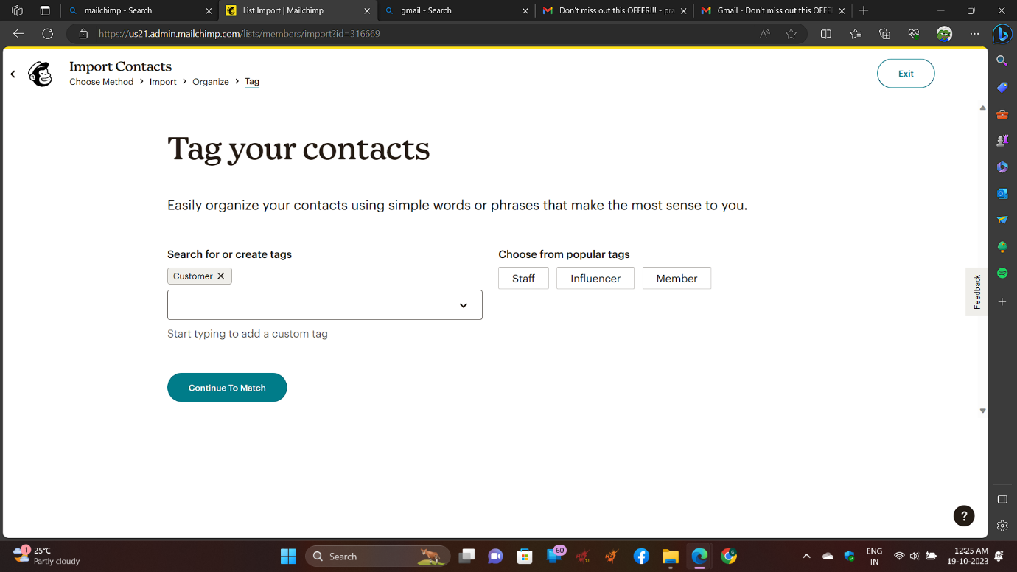

**STEP 9:**

Now match column labels to contact information

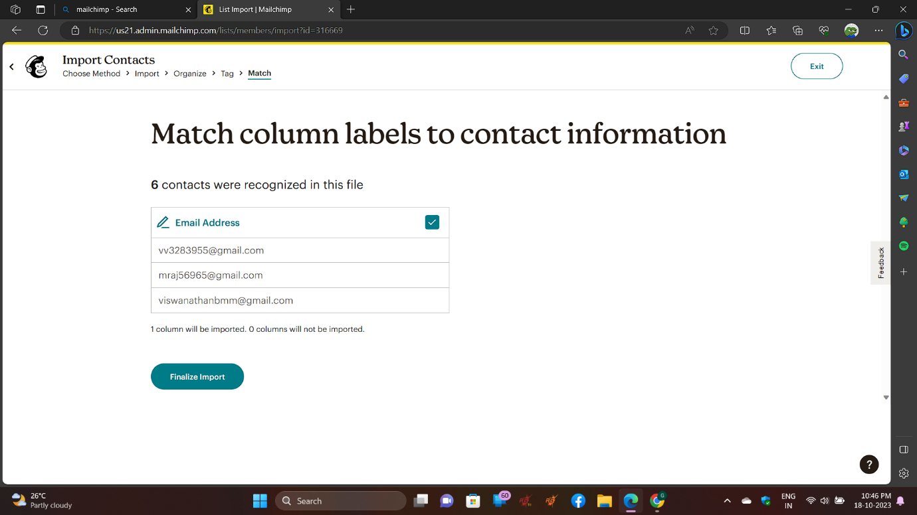

**STEP 10:**

And review and complete your import

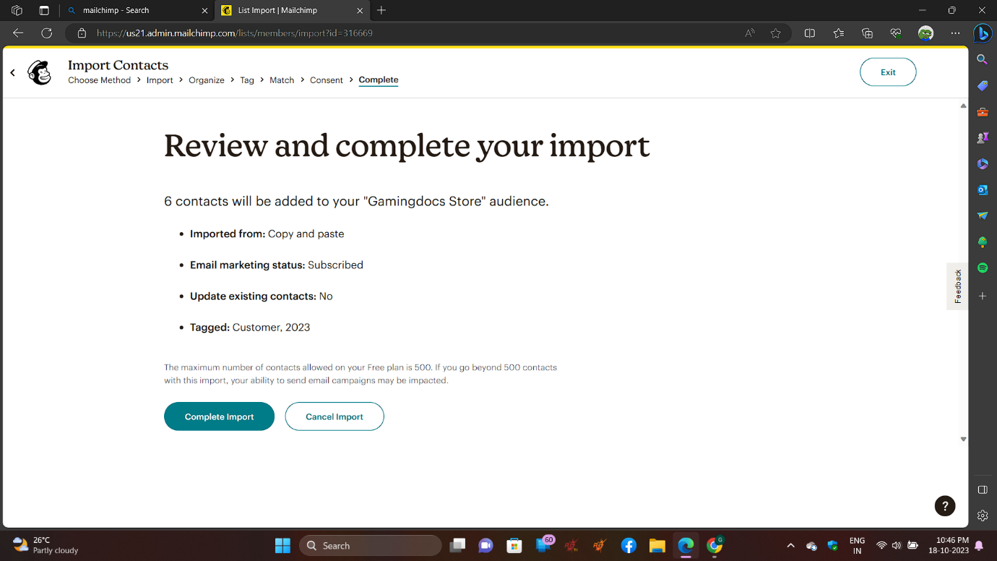

**STEP 11:**

Now your import will be successful.

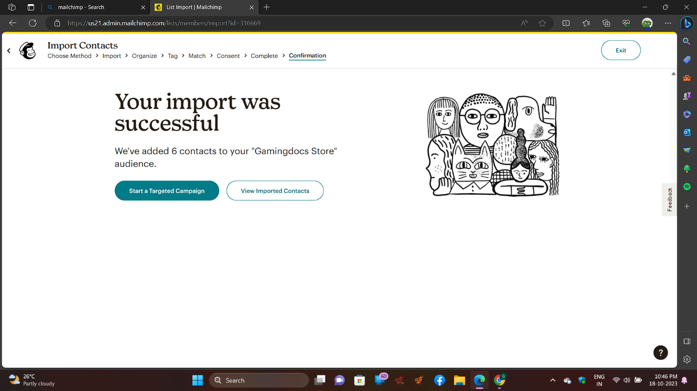

**STEP 12:**

Now add your preview text

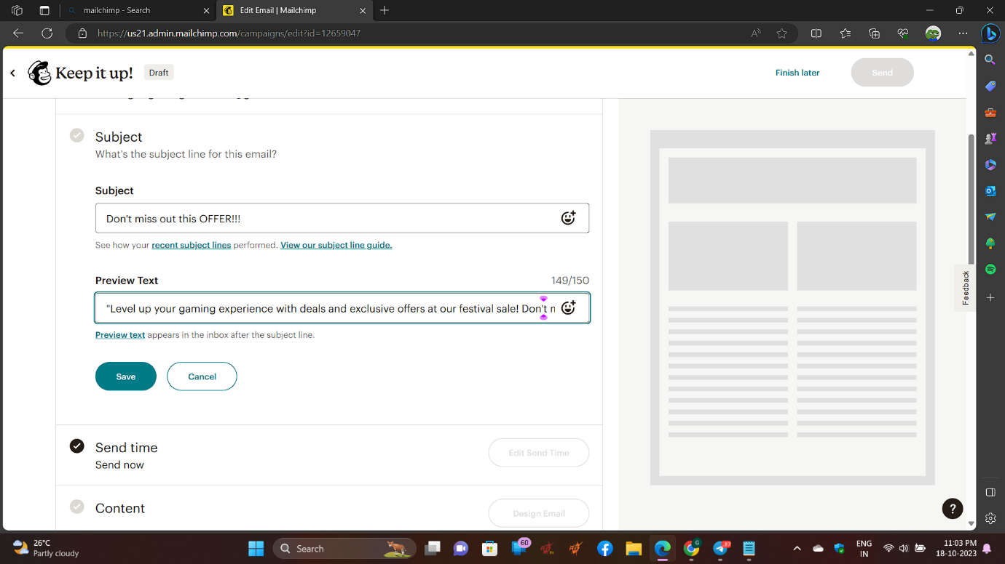

**STEP 13:**

Edit your newsletter

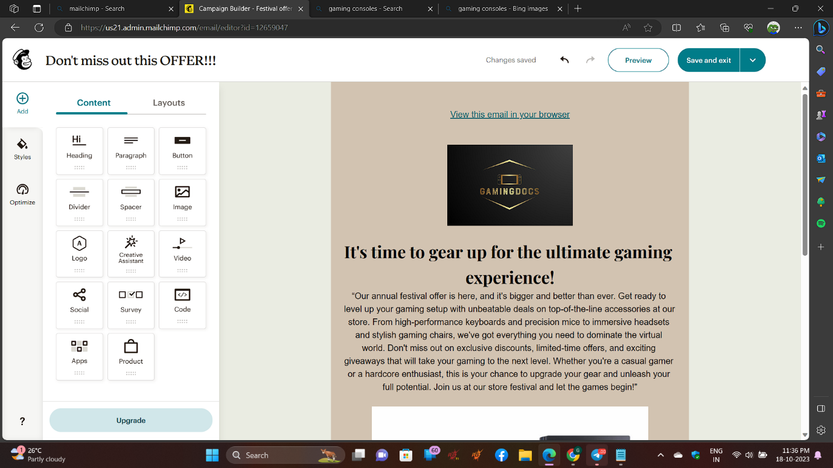

**STEP 14:**

Finalise your settings before sending

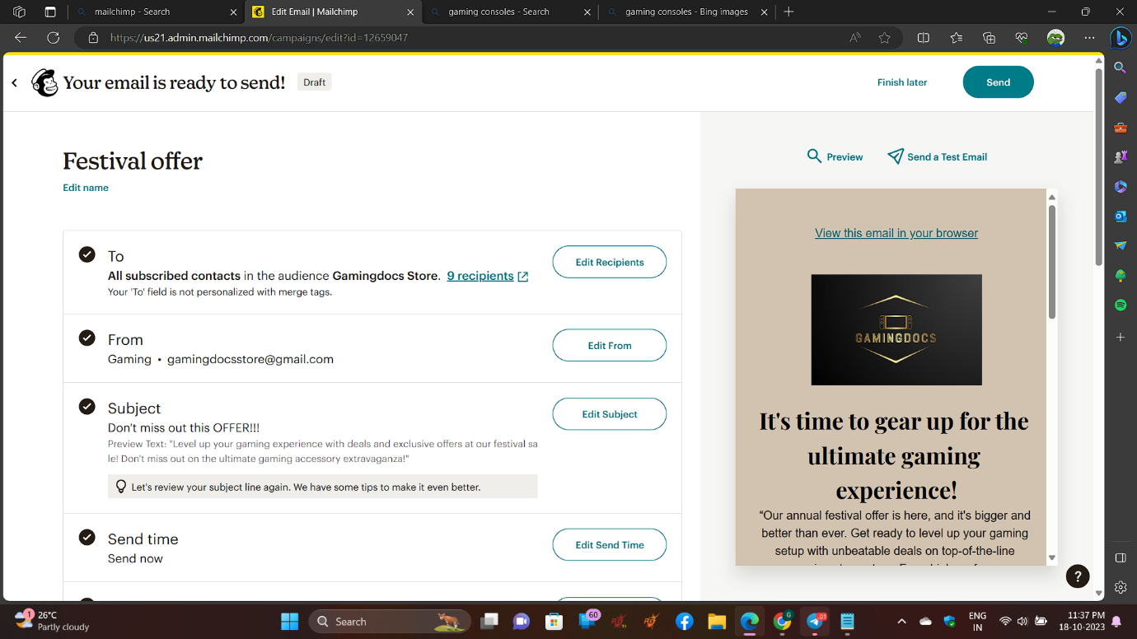

**STEP 14:**

Check out the preview of the newsletter that you designed

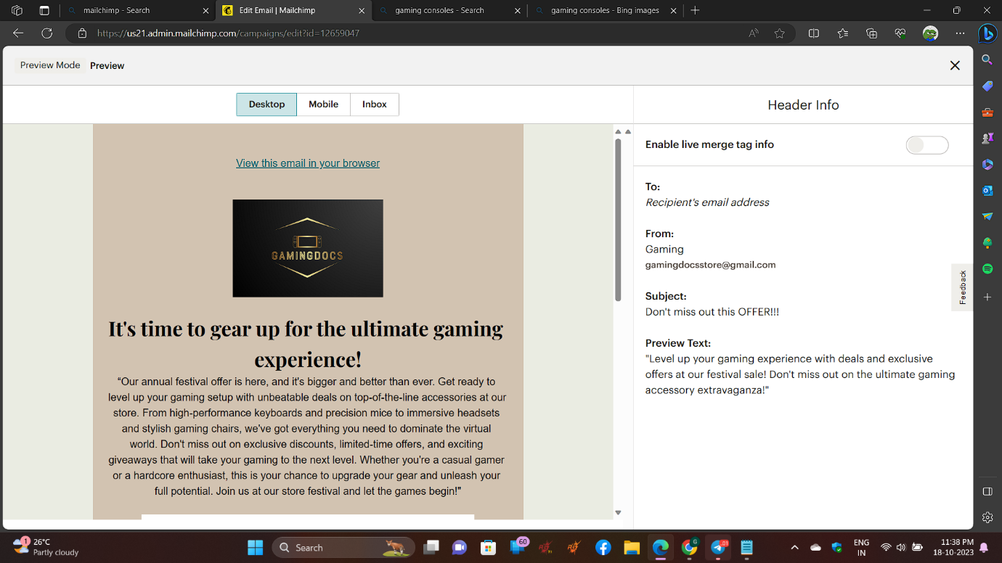

**STEP 15:**

Now it’s time to send a test mail to a selected mail id to check whether everything is correct

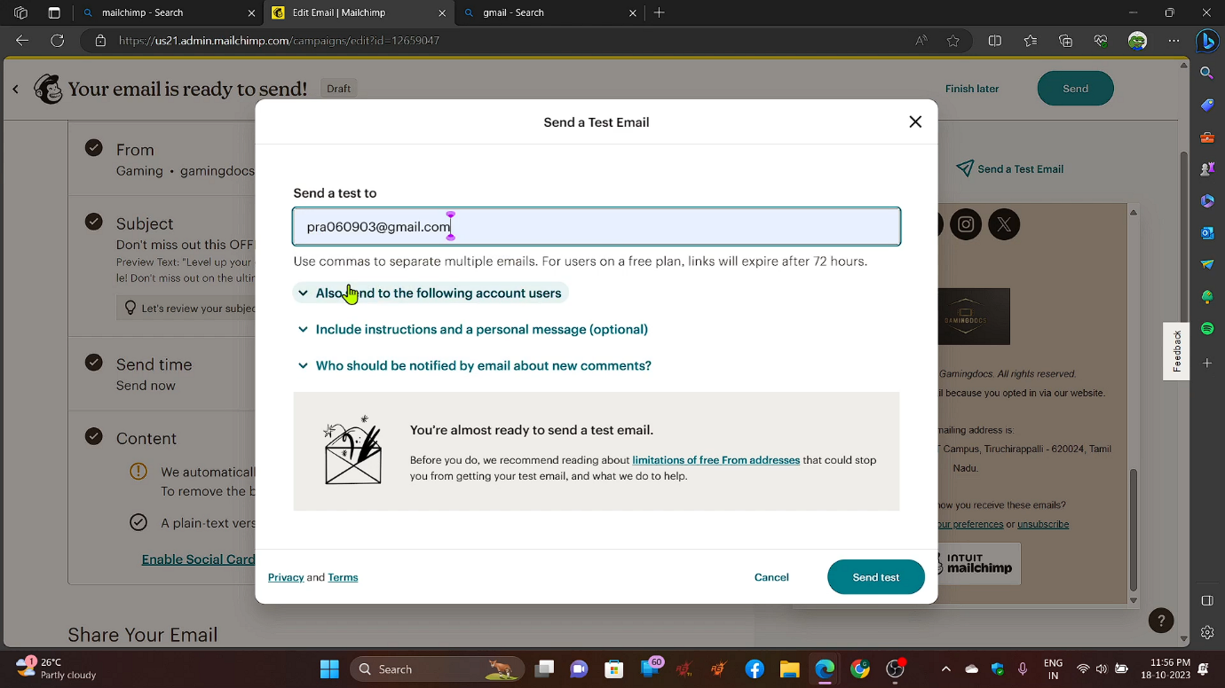

**STEP 16:**

After that a confirmation pop up message will appear

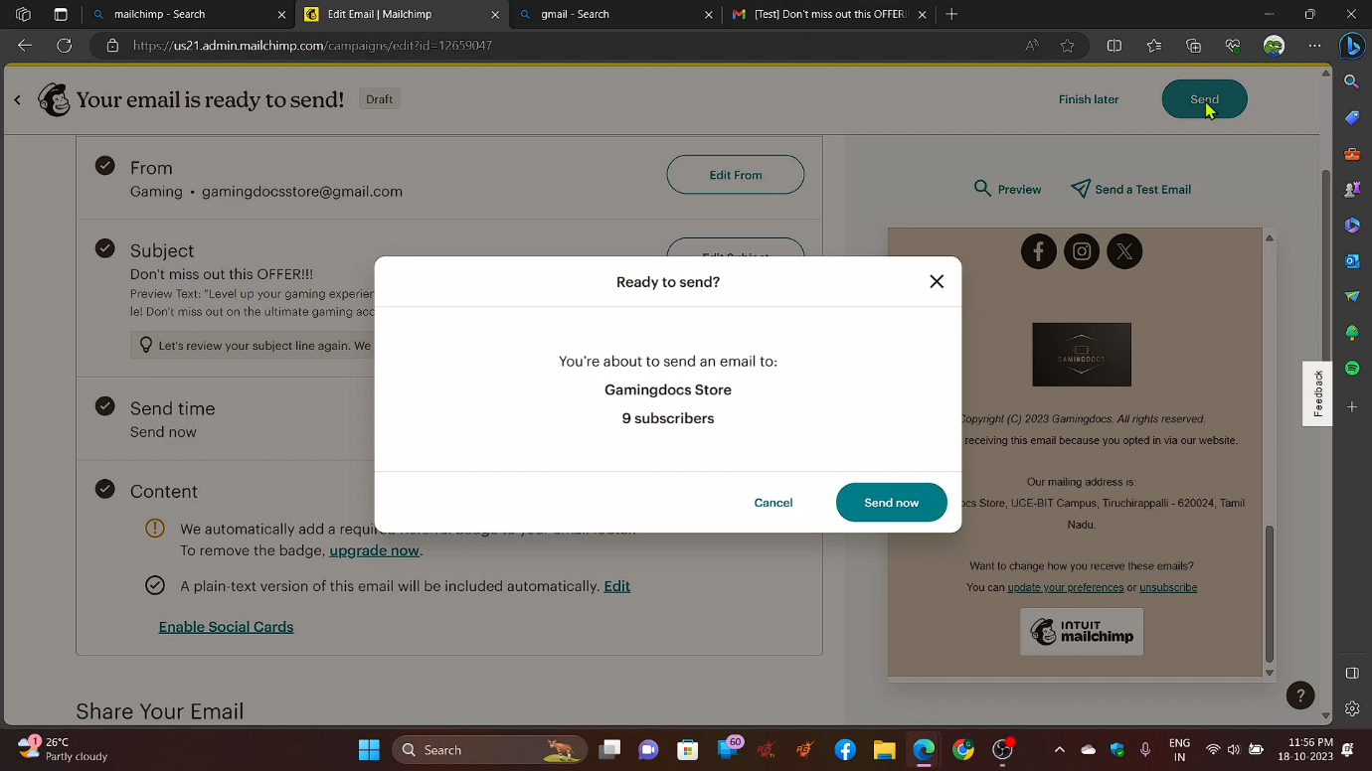

**STEP 17:**

A success window will open indicating that your mail has been sent to the recipients inboxes

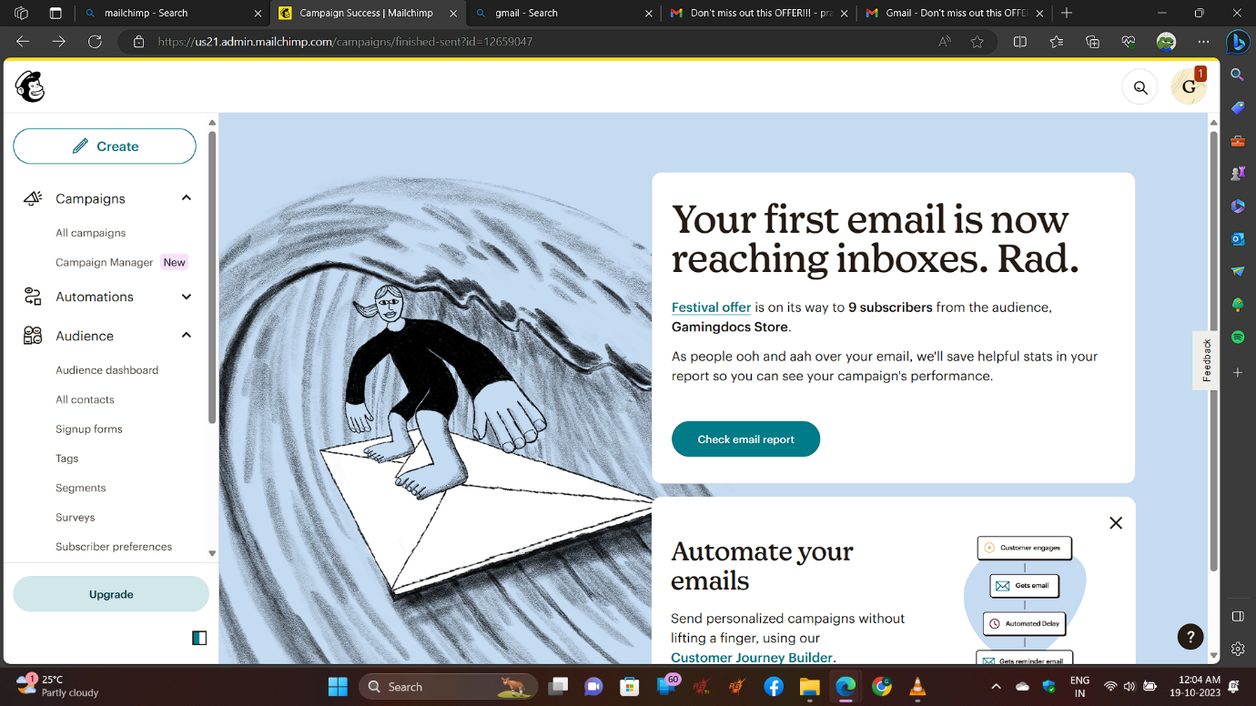

**Conclusion:**

We successfully did an Email campaign using **mailchimp** and verified the result. And the later was documented and presented by out team.